BANKNOTES RECONITION SYSTEM

Natchanon Sayasonti 5988116

Wannaporn Vichaisri 5988266

A Report Submitted in Partial Fulfilment of the Requirements for ITCS476

Faculty of Information and Communication Technology, Mahidol University, 1/2019

**Introduction**

Prior to the adoption of banknotes and flat coins, Thailand used the shell, Baked Clay Coins, and Pot Duang as the money. The first Thai banknote is used since 1912. King Rama 5 had the policy to establish the banknotes. It leads to a growing economic system. People at that time can exchange the product and banknote as obviously.  Thai banknotes are made from cotton fiber, not plastic. The reason why we aim to classify Thai banknote is helping an unknown person such as a foreigner. This tool can help them to classify in a few times.

This project focused on Thai Banknotes which used in King Rama 9, and 10. There are 5 focused types of banknotes which are 20, 50, 100, 500, and 1000. These banknotes have many styles. Therefore, this project will not use all style.

Consequently, the goal of this project is to classify Thai banknotes which one is 20, 50, 100, 500, and 1000 correctly by using a digital image processing method.

**Literature Review**

2017 - Banknotes detected using Image Processing Techniques

*Researcher*

H.Masoumi and N.Panah

*Tool*

MATLAB

*Methodology*

In this paper, an automatic system is proposed. This system consists of two steps. First, the banknote image in the

input will be read by the RGB color model. Then, applying image processing techniques, they get a numerical model that is between 1 and 10. Second, the input banknote image is in black and white models. Then by applying some image processing techniques on the banknote image, the value of money will be determined.

*Scope*

Iranian banknotes

*The Result*

During this process, they managed to eliminate some of the photo noise of input banknotes. It should be noted that the proposed algorithm is very flexible and by working on it much more noise can be removed from the input photo.

2012 - Paper Currency Verification System Based on Characteristic Extraction Using Image Processing

*Researcher*

Rubeena Mirza and Vinti Nanda

*Tool*

LBP tool and MATLAB

*Methodology*

The approach consists of a number of components including image processing, edge detection, image segmentation, characteristic extraction, comparing images. The image processing approach is discussed with MATLAB to detect the features of paper currency.

*Scope*

Indian Paper Currency

*The Result*

Approach suggested from the beginning of image acquisition to converting it to grayscale image and up to the word segmentation has been stated. The work will surely very useful for minimizing the counterfeit currency.

2017 - Currency recognition system using image processing

*Researcher*

Veda Samhita Abburu, Saumya Gupta, S. R. Rimitha, Manjunath Mulimani, and Shashidhar G. Koolagudi

*Tool*

Unknown

*Methodology*

This method works by first identifying the country of origin using certain predefined areas of interest, and then extracting the denomination value using characteristics such as size, color, or text on the note, depending on how much the notes within the same country differ.

*Scope*

20 banknotes in each country consist of Australian Dollars, Canadian Dollars, Chinese Renminbi, American Dollars, Danish Krone, Euro, Hong Kong Dollar, Indian Rupee, Indonesian Rupiah, Kuwaiti Dinar, Mexican Peso, Norwegian Kroner, New Zealand Dollar, Philippine Peso, Japanese Yen, Russian Rubles, Saudi Riyal, Singapore Dollar, Swiss Franc, and UAE Dirhams

*The Result*

They have found that our system is able to accurately recognize most of the countries and denominations correctly (93.3% accuracy, where accuracy is defined as the number of notes correctly identified divided by the total number of notes tested).

2015 - A High-Performance Banknote Recognition System Based on a One-Dimensional Visible Light Line Sensor

*Researcher*

Young Ho Park, Seung Yong Kwon, Tuyen Danh Pham, Kang Ryoung Park, Dae Sik Jeong, and Sungsoo Yoon

*Tool*

semidefinite programming

*Methodology*

An algorithm for recognizing banknotes is required in many fields, such as banknote-counting machines and automatic teller machines (ATM). Due to the size and cost limitations of banknote-counting machines and ATMs, the banknote image is usually captured by a one-dimensional (line) sensor instead of a conventional two-dimensional (area) sensor. Therefore, they propose in this paper a novel method for pre-classifying banknotes’ direction for implementation in banknote recognition systems.

*Scope*

United State dollar

*The Result*

This report showed that the error rate for the proposed pre-classification method was lower than that of other methods. In addition, the banknote-recognition error rate after pre-classifying the banknote’s direction was as low as 0.114%. However, incorrect recognition occurred when part of the banknote was damaged or when contaminants were present in the upper or lower region of the banknote.

2018 - Decision tree model for classification of fake and genuine banknotes using SPSS

*Researcher*

Akanksha Upadhyaya, Vinod Shokeen, and Garima Srivastava

*Tool*

The decision tree model is built using IBM SPSS tool.

*Methodology*

This paper proposes an effective predictive model based on a machine learning technique for authentication of banknotes, which can predict with good accuracy that whether the given banknote is fake or genuine.

*Scope*

Dutch, German, English, and US counterfeit banknotes

*The Result*

The model shows 91% of accuracy. This model can be used for the classification of fake and genuine currency of different countries. The work can be extended by comparing this model with other predictive models for the calculated values of different currencies notes in terms of four independent variables mentioned in the paper.

2017 - Banknotes Recognition in Real Time Using ANN

A thesis submitted to School of Engineering, Computer and Mathematical Sciences, Auckland University of Technology by Yueqiu Ren.

*Researcher*

Yueqiu Ren

*Tool*

MATLAB

*Methodology*

 BPMN Classifiers and other ANN classifiers

*Scope*

New Zealand banknotes including 5 NZD, 10 NZD, 20 NZD, 50 NZD, and 100 NZD

*The Result*

As the recognition results of 500 test images, with 100 test images for each class, the average F-measure of every combination is beyond 0.88 when using the banknote images captured by webcam for training, while not all the combinations can achieve this when using the scanned banknote images for training.

2016 - IMAGE PROCESSING BASED FEATURE EXTRACTION OF CURRENCY NOTES

*Researcher*

MOHAMMAD ARIF

*Tool*

MATLAB

*Methodology*

Direction (front, rotated front, back, and rotated back) and face value, neural network based bill recognition and verification method, the learning vector quantization (LVQ) method

*Scope*

Numerous Indian Currency notes of value 100

*The Result*

Approaches suggested from the beginning of scanning a document to converting it to binary image, thresholding, morphological filtering and word segmentation has been successfully stated In our current approach, the whole character itself was used as a feature. Selection of feature extraction method is the single most important factor in achieving high recognition performance.

2019 - Perfecting Counterfeit Banknote Detection - A Classification Strategy

*Researcher*

Malladi Tejasvi, A.Nayeemulla Khan, A.Shahina

*Tool*

Machine Learning

*Methodology*

detect portraits in the banknotes using CNN

*Scope*

1372 greyscale bank note images each of size 400x400 pixels

*The Result*

Perfect classification (100%) was achieved using ANN, SVM and KNN. The logistic regression followed by decision tree and simple perceptron have also performed well by detecting fake notes at 99.27%, 98.91% and 98.91% respectively.

2018 - Exploratory analysis for the identification of false banknotes using portable X-ray Fluorescence spectrometer

*Researcher*

M.A. Zamalloa Jaraa, C. Luízar Obregónb, C. Araujo Del Castilloa

*Tool*

portable X-ray Fluorescence spectrometer

*Methodology*

detect portraits in the banknotes using CNN

*Scope*

the 200 Nuevos Soles banknotes

*The Result*

The results from the semi quantitative elemental analysis, using pXRF, show that the chemical composition of the ink used in the false banknotes is different to that of the original ones.

2018 - Analysis of Banknote Authentication System using Machine Learning Techniques

*Researcher*

Sumeet Shahani, Aysha Jagiasi, Priya R. L.

*Tool*

Machine Learning

*Methodology*

two supervised learning techniques

*The Result*

The results of training and test data do not show much difference except for sensitivity of SVM. The training sensitivity of SVM is 98.68% and the test sensitivity is 98.69%. BPN gives 100% detection rate and SVM gives 98.90% success rate.The result shows that back-propagation neural network outperforms support vector machine and gives 100% success rate.

**Methodology**

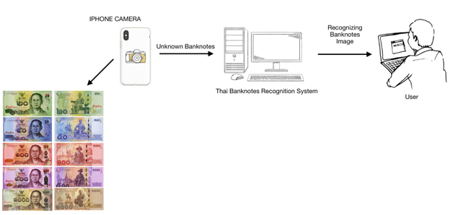

Figure 1: Conceptual Diagram

**Structure Chart**

Thai banknote recognition system consists of five main process modules:

1) image acquisition

2) image preprocessing

3) feature extraction

4) image recognition

5) result presentation

**Image acquisition**

The whole data which are images should be taken from bird-eye-views as input in this system. The banknotes have to set the same environment. While taking a picture, the mobile has to available a flashlight mode. All of the banknotes, which are a dataset, have to place in a horizontal line.

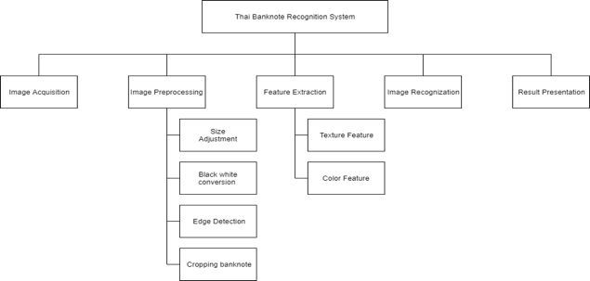

Figure 2: Structure Chart

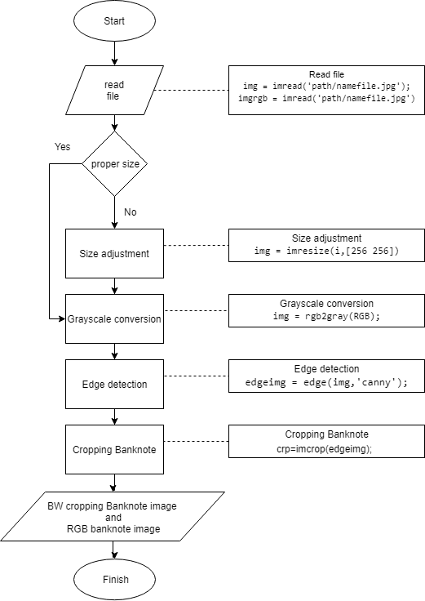

Figure 3: Image Preprocessing Chart

1. Size adjustment

After reading two files, if the picture is an incorrect size in case of images come from different devices, the picture will step in size adjustment process. This process will resize two photos to be the same size.

2. Grayscale conversion

Make one photo to be grayscale for using in texture feature. For the RGB picture, there's no need to step in this process because it will use in the color feature process.

3. Edge detection

After grayscale conversion, the next process is edge detection by using a candy filter because it is suitable for Sobel detection.

4. Cropping Banknote

The unwanted part of the image will be removed by this process. It will be left only the bank. Then the picture is ready to use in the image recognition process.

**Feature extraction**

There are two features that were used in the Thai Banknote Recognition System:

1. Texture feature

2. Color feature

The system will keep the mean color of each color into the excel file

**Image Recognition**

After preparing an excel file, there will be an image recognition method. The technique which this system used to compare two images is Euclidean distance. This is owing to a Euclidean distance formula can be used to calculate the distance between two data points in a plane. If the value is very few, it meant that two datasets are very similar as well. The equation is below in figure 4.

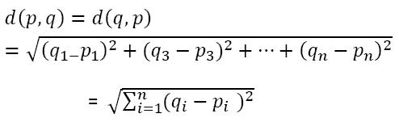

Figure 4:  Euclidean distance equation

**Result Presentation**

There will be 2 axes charts which are upload pictures and result in pictures. The edit bar which below those charts represents the name of the file. There are also 3 buttons which are the upload button, the train button, and the recognition button (test). As shown in figure 5.

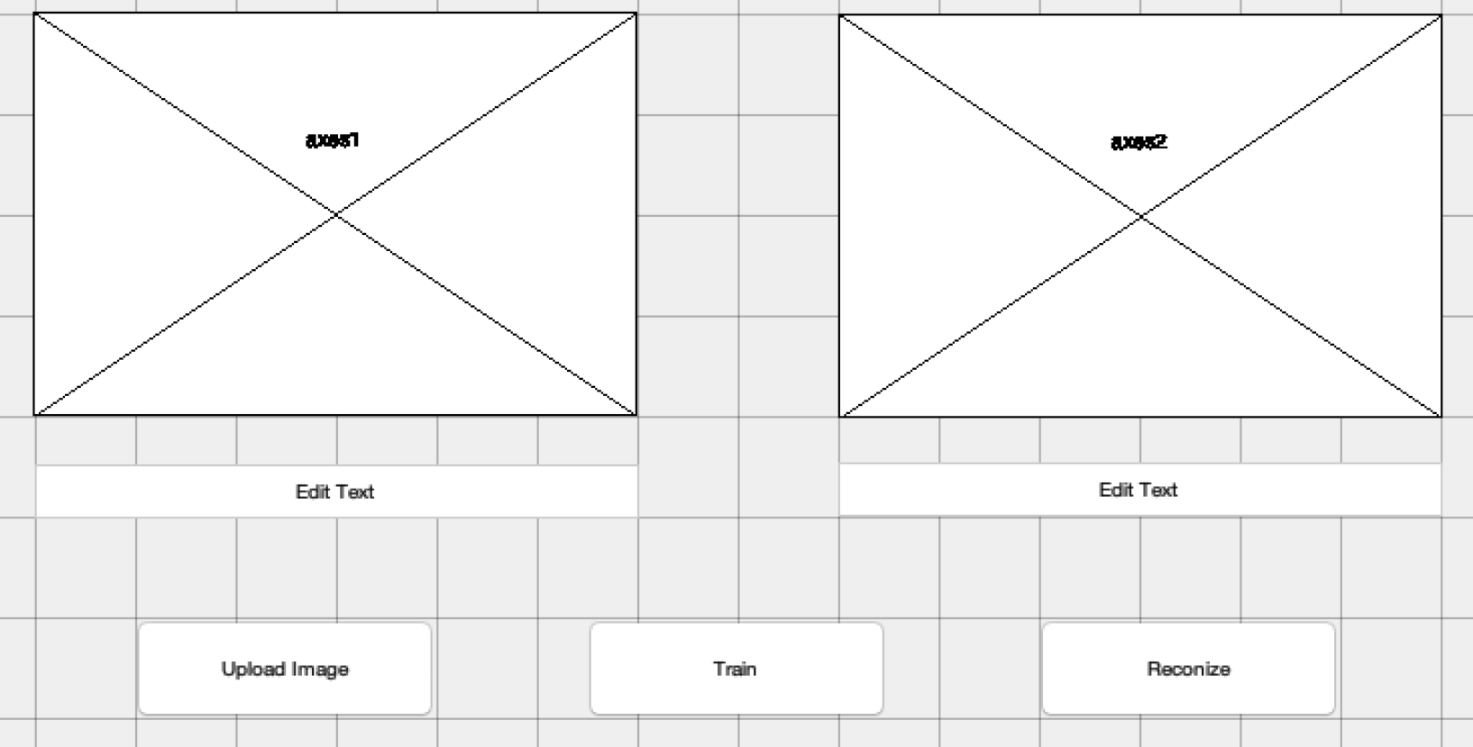

Figure 5: MATLAB result interface

**Graphic User Interface**

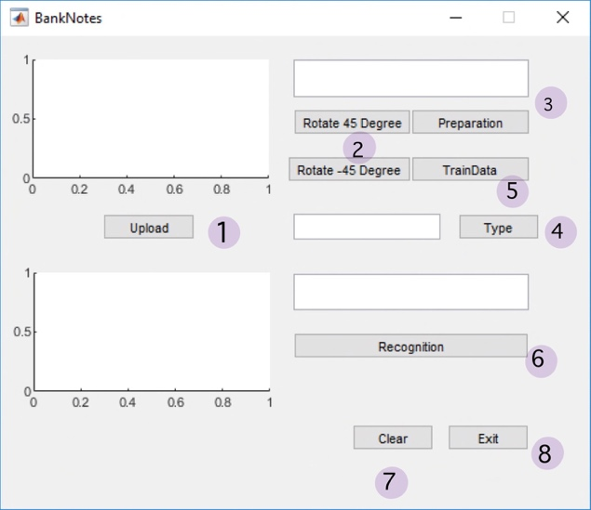

Figure 6: User Interface

**Implementation**

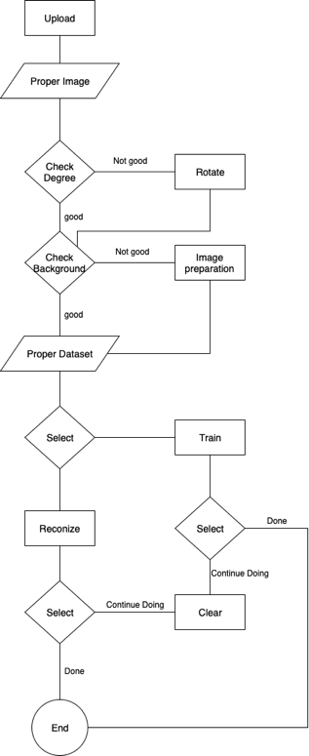

Figure 7: Flow chart of Implementation

1.Upload

global image;

global pic;

global filename;

image = strcat(pathname,filename);

pic = imread(image);

axes(handles.axes1); imshow(pic);

axes(handles.axes2); cla;

set(handles.edit1,'string',filename);

2. Rorate 45 or -45 degree

global pic

pic = imrotate(pic,45);

% imrotate(pic,-45)%

axes(handles.axes1); imshow(pic);

3. Preparation [Crop an object]

global pic;

hsvImage = rgb2hsv(pic);

sImage = hsvImage(:, :, 2);

mask = sImage > 0.1;

mask = bwareafilt(mask,1);

mask = imfill(mask, 'holes');

props = regionprops(logical(mask),

'BoundingBox');

croppedImage = imcrop(pic, props.BoundingBox);

axes(handles.axes1);

imshow(croppedImage);

4. Color Recognition

global pic;

 r=mean(mean(pic(:,:,1)));

 g=mean(mean(pic(:,:,2)));

 b=mean(mean(pic(:,:,3)));

 Thou = abs(r-b);

 %Thou > 3 is not 1000%

 onethou = false;

 if Thou <=3

     onethou = true;

 end

 if (r > g) && (r > b)  && (onethou == false)

     set(handles.edit3,'string','100');

         elseif (b>r) && (b>g)&& (onethou == false)

     set(handles.edit3,'string','50');

 elseif (g>b) && (g>r)  && (onethou == false)

      set(handles.edit3,'string','20');

         else

     set(handles.edit3,'string','1000 or 500');

 end

5. Preparing data for Euclidean distance Recognition [Train]

global pic;

global filename;

global excel;

excel = 'E:\MATLAB\R2018\bin\Project\DB_Train.xlsx';

tab=xlsread(excel);

[rr,cc]=size(tab);

% ............................ Calculate Features

 mred=mean(mean(pic(:,:,1)));

 mgreen=mean(mean(pic(:,:,2)));

 mblue=mean(mean(pic(:,:,3)));

 gray=rgb2gray(pic);

 mgray=mean(mean(gray));

 %energy

 gray=rgb2gray(pic);

 glcm = graycomatrix(gray, 'o', [0,1]);

 S = graycoprops(glcm);

 energy = S.Energy*100;

 %entropy

 rngfil = rangefilt(pic);

 entro = entropy(rngfil)*100;

 %homo

 Homo = S.Homogeneity*100;

 %contrast

 Contrast = S.Contrast*100;

 %Correlation

 correlation=S.Correlation*100;

% ............................... calculate Excel Cell

 cell1=cat(2,'A',num2str(rr+2));

 cell2=cat(2,'B',num2str(rr+2));

 cell3=cat(2,'C',num2str(rr+2));

 cell4=cat(2,'D',num2str(rr+2));

 cell5=cat(2,'E',num2str(rr+2));

 cell6=cat(2,'F',num2str(rr+2));

 cell7=cat(2,'G',num2str(rr+2));

 cell8=cat(2,'H',num2str(rr+2));

 cell9=cat(2,'I',num2str(rr+2));

 cell10=cat(2,'J',num2str(rr+2));

% .................................. Write Excel Data

 xlswrite(excel,[{filename}],1,cell1);

 xlswrite(excel,[mred],1,cell2);

 xlswrite(excel,[mgreen],1,cell3);

 xlswrite(excel,[mblue],1,cell4);

 xlswrite(excel,[mgray],1,cell5);

 xlswrite(excel,[entro],1,cell6);

 xlswrite(excel,[energy],1,cell7);

 xlswrite(excel,[Homo],1,cell8);

 xlswrite(excel,[Contrast],1,cell9);

 xlswrite(excel,[correlation],1,cell10);

 system('taskkill /F /IM EXCEL.EXE');

6. Euclidean distance Recognition

global pic;

global excel;

excel = 'E:\MATLAB\R2018\bin\Project\DB_Train.xlsx';

datasetpath ='E:\MATLAB\R2018\bin\Project\Dataset\';

tab=xlsread(excel);

[rr,cc]=size(tab);

% ............................ Calculate Features

 data(1)=mean(mean(pic(:,:,1)));

 data(2)=mean(mean(pic(:,:,2)));

 data(3)=mean(mean(pic(:,:,3)));

 gray=rgb2gray(pic);

 data(4)=mean(mean(gray));

 gray=rgb2gray(pic);

 glcm = graycomatrix(gray, 'o', [0,1]);

 S = graycoprops(glcm);

 rngfil = rangefilt(pic);

 data(5) = entropy(rngfil)*100;

 data(6) = S.Energy*100;

 data(7) = S.Homogeneity*100;

 data(8) = S.Contrast*100;

 data(9) =S.Correlation*100;

% ............................ Matching

min=999;

rec=0;

for i=1 : rr

diff=0;

    for j=1 : cc

        diff=diff+sqrt(power(tab(i,j)-data(j),2));

    end

if (diff <=100)

    min=diff;

    rec=i;

end

end

if (rec ~= 0)

    %found

   cellx=cat(2,'A',num2str(rec+1));

    %cellx = A3

   [~,ff]=xlsread(excel,1,cellx);

   file=ff{1};

   imgfile = strcat(datasetpath,file);

   result=imread(imgfile);

   axes(handles.axes2); imshow(result);

file= strcat('Found : ',file);

   set (handles.edit2, 'string',file);

else

    % not found

   fig=zeros(250,300);

   axes(handles.axes2); imshow(fig);

   set (handles.edit2, 'string','NOT FOUND');

end

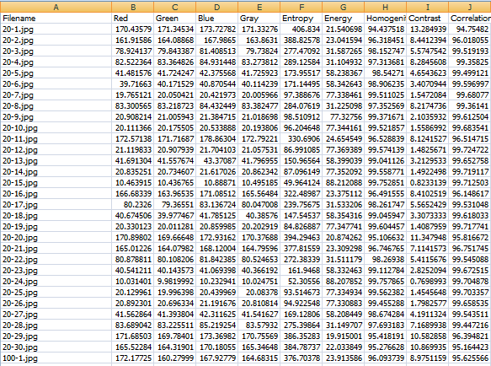

Figure 8: Data table from excel file

7. Clear a Data

axes(handles.axes1); cla;

axes(handles.axes2); cla;

set (handles.edit1, 'string','                         ');

set (handles.edit2, 'string','                         ');

8. Exit the System

Close

**Experiment Result**

Thai Banknote Recognition System can recognize banknotes by 2 techniques which are Color Recognition and Euclidean distance Recognition. The experiment uses 12 pictures for each type of bank from the internet. For color recognition technique, it can recognize all pictures including both match and not match. Another technique which is Euclidean distance recognition can find only 1 match from all 60 banknotes.

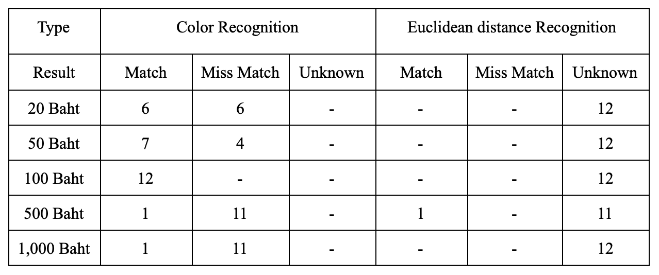Figure 9: Result table from the experiment

**References**

[1] N.Panah and H.Masoumi, “Banknotes detected using Image Processing Techniques (2017)”, URL: https://www.ijcsmc.com/docs/papers/May2017/V6I5201710.pdf

[2] Rubeena Mirza and Vinti Nanda, “Paper Currency Verification System Based on Characteristic Extraction Using Image Processing (2012)”, URL: https://www.semanticscholar.org/paper

/Currency-Verification-System-Based-on-Extraction-Mirza-Nanda/0e8f89e2dae48ed45a6ba07b5b9523bebd64c015

[3] Vedasamhitha Abburu, Saumya Gupta, S. R. Rimitha, Manjunath Mulimani, and Shashidhar G. Koolagudi, “Currency recognition system using image processing (2017)”, URL: https://www.researchgate.net/publication

/323056402_Currency_recognition_system_using_image_processing

[4] Young-Ho Park, Seung Yong Kwon, Tuyen Danh Pham, Kang Ryoung Park, Dae Sik Jeong, and Sungsoo Yoon, ”A High-Performance Banknote Recognition System Based on a One-Dimensional Visible Light Line Sensor (2015)”, URL: https://www.researchgate.net/publication/278792894_A_High_Performance_Banknote_Recognition_System_Based_on_a_One-Dimensional_Visible_Light_Line_Sensor

[5] Akanksha Upadhyaya, Vinod Shokeen, and Garima Srivastava, “Decision tree model for classification of fake and genuine banknotes using SPSS (2018)”, URL: https://www.researchgate.net/publication

/330736939_Decision_tree_model_for_classification_of_fake_and_genuine_banknotes_using_SPSS

[6] Yueqiu Ren, “Banknotes Recognition in Real Time Using ANN”, URL: https://pdfs.semanticscholar.org/14a9/d6b7b99ea411c1fe85ab2869cb27209d9635.pdf

[7] MOHAMMAD ARIF, “IMAGE PROCESSING BASED FEATURE EXTRACTION OF CURRENCY NOTES”, URL: https://www.irjet.net/archives/V3/i4/IRJET-V3I4517.pdf

[8] Malladi Tejasvi, A.Nayeemulla Khan, A.Shahina, “Perfecting Counterfeit Banknote Detection - A Classification Strategy”, URL: https://www.ijitee.org/wp-content/uploads/papers/v8i6/F3597048619.pdf

[9] M.A. Zamalloa Jaraa, C. Luízar Obregónb, C. Araujo Del Castilloa, “Exploratory analysis for the identification of false banknotes using portable X-ray Fluorescence spectrometer”, URL: https://www.sciencedirect.com/science/article/pii/S0969804317300167

[10] Sumeet Shahani, Aysha Jagiasi, Priya R. L., “Analysis of Banknote Authentication System using Machine Learning Techniques”, URL: https://www.ijcaonline.org/archives/volume179/number20/shahani-2018-ijca-916343.pdf